Sequential Cohesion

📌 Definition:
# Source: AI Source: Provided by: [Data Path: Persons Table -> ID Column: 1, Name_En Column: Motasem Essam] -> From: [Chatgpt (GPT‑5 Mini)] on [12/9/2025]
Sequential Cohesion occurs when elements of a class/module are arranged in a sequence, where the output of one operation becomes the input of the next.

🧠 Simple idea:
# Source: AI Source: Provided by: [Data Path: Persons Table -> ID Column: 1, Name_En Column: Motasem Essam] -> From: [Chatgpt (GPT‑5 Mini)] on [12/9/2025]
“Step-by-step processing (output → next input)” 🔄

🔍 Key characteristics:
# Source: AI Source: Provided by: [Data Path: Persons Table -> ID Column: 1, Name_En Column: Motasem Essam] -> From: [Chatgpt (GPT‑5 Mini)] on [12/9/2025]
- 🔗 Operations are dependent in sequence
- 🔄 Output of one step feeds the next
- 🧩 Moderately strong cohesion (but not as strong as functional)
- ⚙️ Common in data processing pipelines

📊 Example:
# Source: AI Source: Provided by: [Data Path: Persons Table -> ID Column: 1, Name_En Column: Motasem Essam] -> From: [Chatgpt (GPT‑5 Mini)] on [12/9/2025]
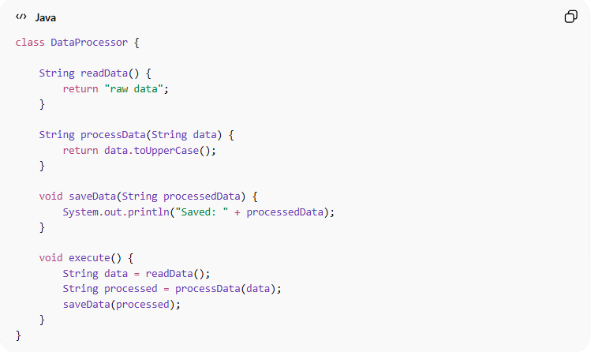
class DataProcessor {

String readData() {
return "raw data";
}

String processData(String data) {
return data.toUpperCase();
}

void saveData(String processedData) {
System.out.println("Saved: " + processedData);
}

void execute() {
String data = readData();
String processed = processData(data);
saveData(processed);
}
}
- ✅ readData() → processData() → saveData()
- ✅ Each step’s output is used by the next → sequential flow

🛡️ Avoiding Sequential Cohesion Example:
# Source: AI Source: Provided by: [Data Path: Persons Table -> ID Column: 1, Name_En Column: Motasem Essam] -> From: [Chatgpt (GPT‑5 Mini)] on [12/9/2025]
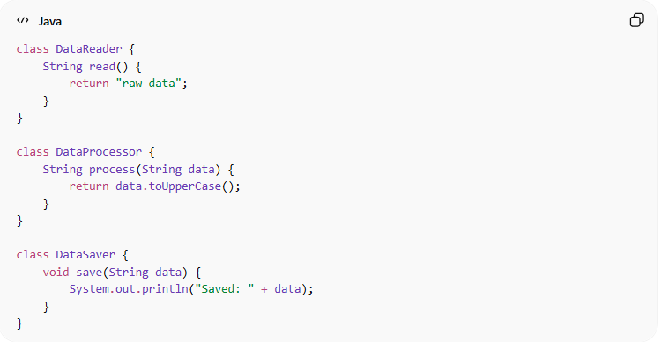
class DataReader {
String read() {
return "raw data";
}
}

class DataProcessor {
String process(String data) {
return data.toUpperCase();
}
}

class DataSaver {
void save(String data) {
System.out.println("Saved: " + data);
}
}

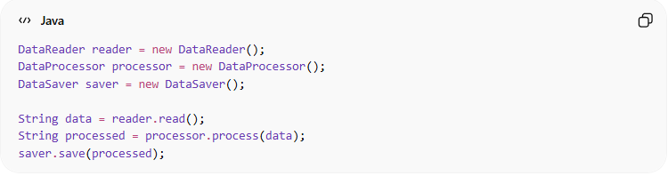
DataReader reader = new DataReader();
DataProcessor processor = new DataProcessor();
DataSaver saver = new DataSaver();

String data = reader.read();
String processed = processor.process(data);
saver.save(processed);
✅ Key improvements:
- Each class has single responsibility (high cohesion)
- Components are independent and reusable
- Steps can be modified or replaced بسهولة without affecting others
- Easier to test each part separately

⚙️ Best Practice:
# Source: AI Source: Provided by: [Data Path: Persons Table -> ID Column: 1, Name_En Column: Motasem Essam] -> From: [Chatgpt (GPT‑5 Mini)] on [12/9/2025]
- Keep each step clear and focused
- Avoid making steps overly dependent or complex
- Split into smaller modules if needed
- Use when natural data flow exists

